Chapter 18, Solution 18.

(a) 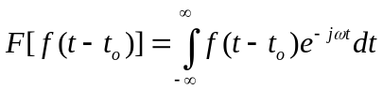
Let
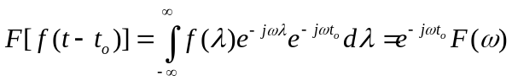

(b) Given that 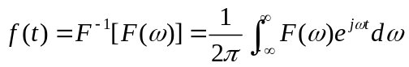

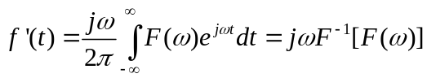
or
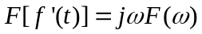

(c ) This is a special case of the time scaling property when a = –1. Hence,

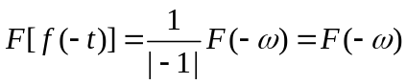

(d) 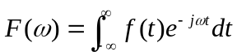
Differentiating both sides respect to ω and multiplying by t yields
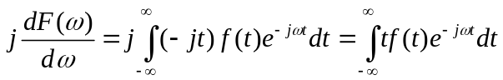
Hence,
